Experiment No.9

Aim: To study, analyze, design and implement a traffic signal system.

# Objectives:

1. To understand practical traffic Control systems
2. To analyze and design traffic Control system.
3. Applying knowledge of counters and timers for design and development of traffic Control systems.
4. To understand practical issues / difficulties in realization of in actual traffic Control systems.

# Equipment:

Resistors, Capacitors, Diodes, LED’s, Timer(IC 555) and Counter(IC 4017) IC, NAND gate(7400) IC, Bread Board, Connecting Wires, Battery, etc.

# Theory:

Traffic signal systems are signaling devices positioned at road intersections and other locations to control competing flows of traffic. They alternate the right-of-way of road users by displaying lights of a standard color. They make use of three colors; each provides distinct signal that a car must follow. There’s a green light allowing a car to proceed in the direction denoted, a yellow light denoting prepare to stop short of the intersection, and a red light prohibiting it to proceed.

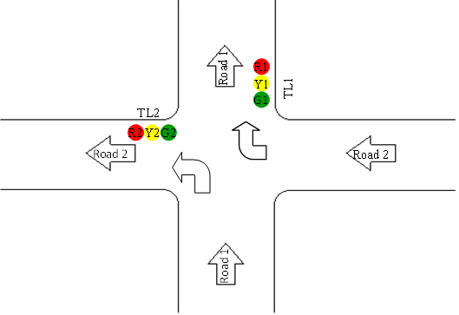

The main goal in this project is to design a one-way road intersection. That is, a car from road 1 can go straight or turn left but is unable to turn right. Also, a car from road 2 can go straight or turn right but is unable to turn left.

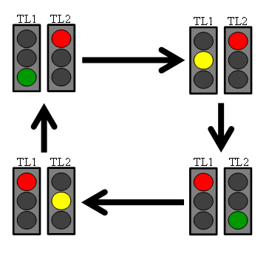

# Circuit Diagram:

The IC 4017 is a versatile IC of the CMOS family which has got wide range of applications. Internally it consists of a 10 stage decade counter/divider. When a clock pulse is applied to it externally, its outputs become logic 'hi' and 'lo' sequentially (one after the other).

The **555 timer IC** is an integrated circuit (chip) used in a variety of timer, pulse generation, and oscillator applications. The 555 can be used to provide time delays, as an oscillator, and as a flip-flop element.

**Timing Diagram:**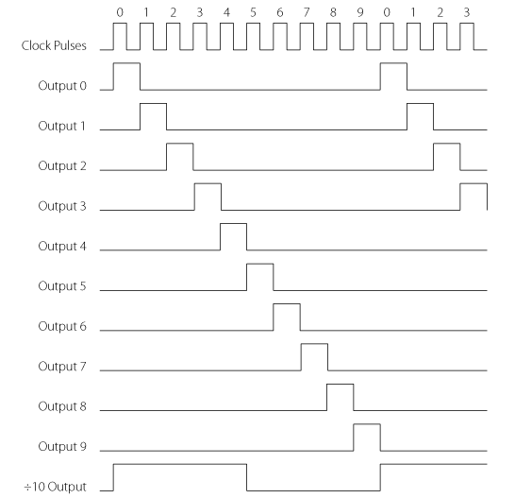

# design

## Basic version

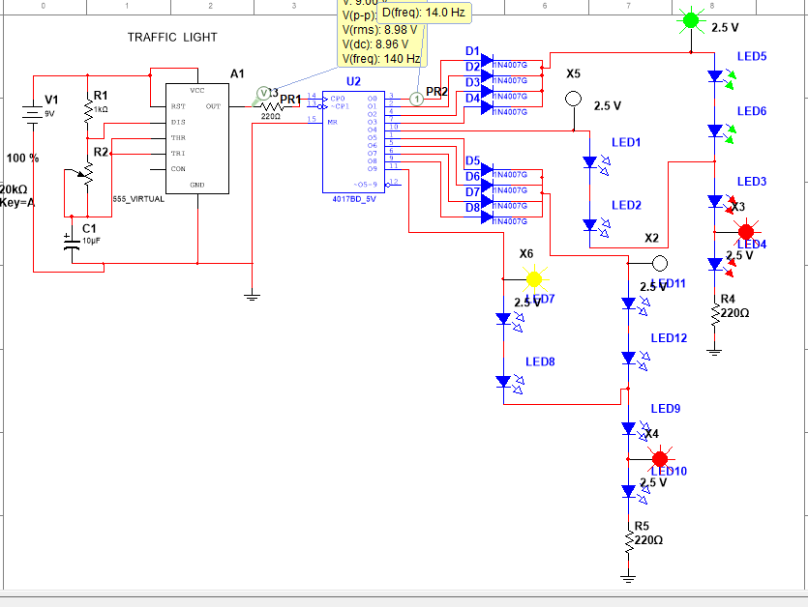

## Modified version

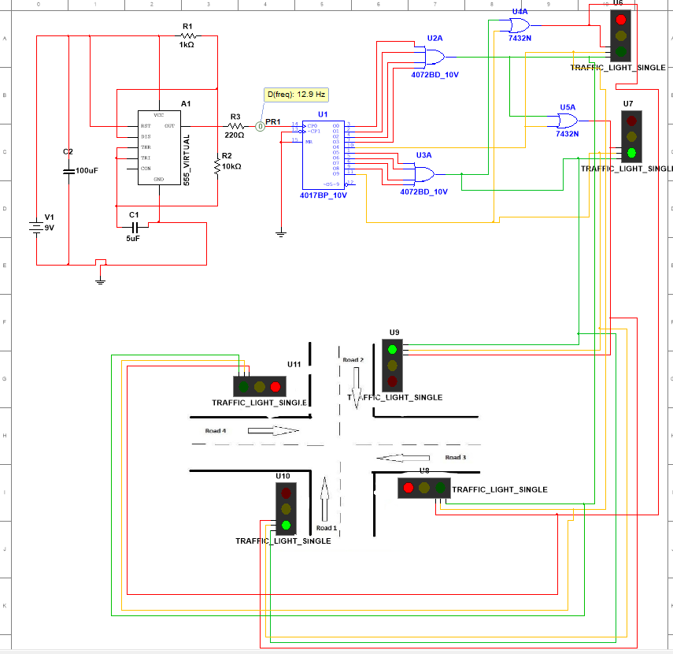

# Observations:

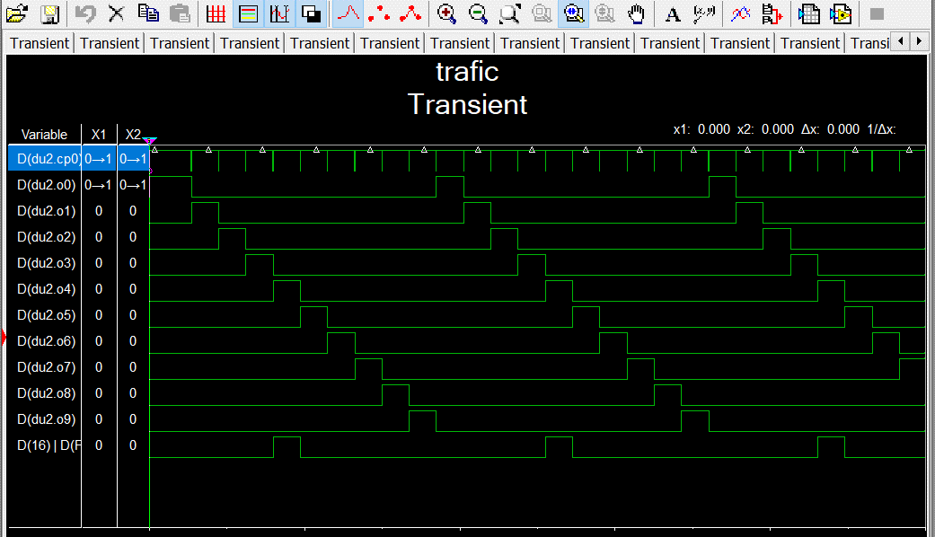

# Results:

Observation has been successfully carried out and circuit design of traffic light is working well in simulation.

# Conclusion:

counters and timers for design and development of traffic Control systems has been implemented successfully.

# What did you learn?

**I learnt how the logic of traffic signal works and understood that how we are implementing digital electronics in daily life.**